**File Permission Task**

Create a file with .txt extension (/home/demo.txt). Change the permission set of that file, so that any user can read it, group can read/write & owner can read/write/execute it.

* Create a file with .txt extension (/home/demo.txt).

**touch demo.txt**

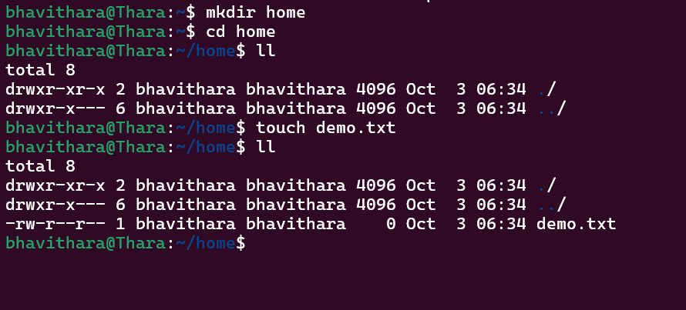

* Change the permission set of that file, so that any user can read it, group can read/write & owner can read/write/execute it

**chmod 764 demo.txt**

**Read = 4 , Write = 6 , Execute = 1**

